1. Implement Tic –Tac –Toe game.

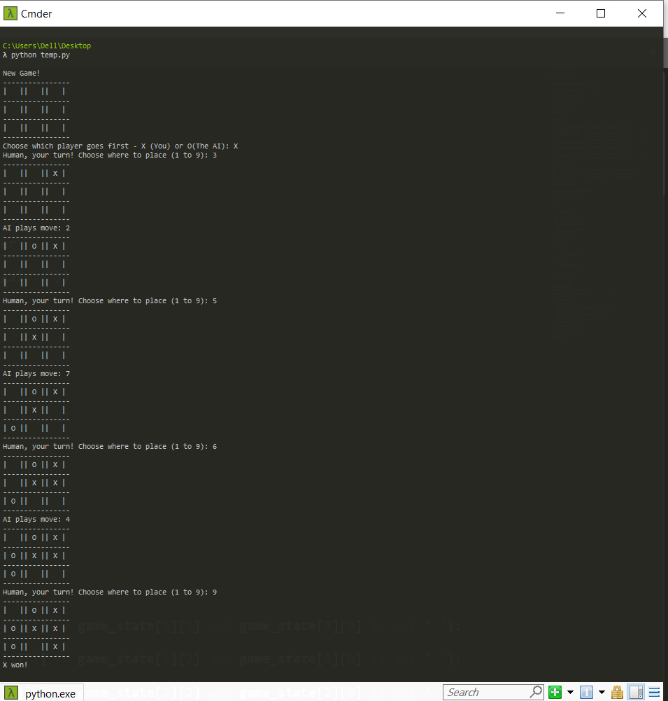

1. Solve 8 puzzle problem. 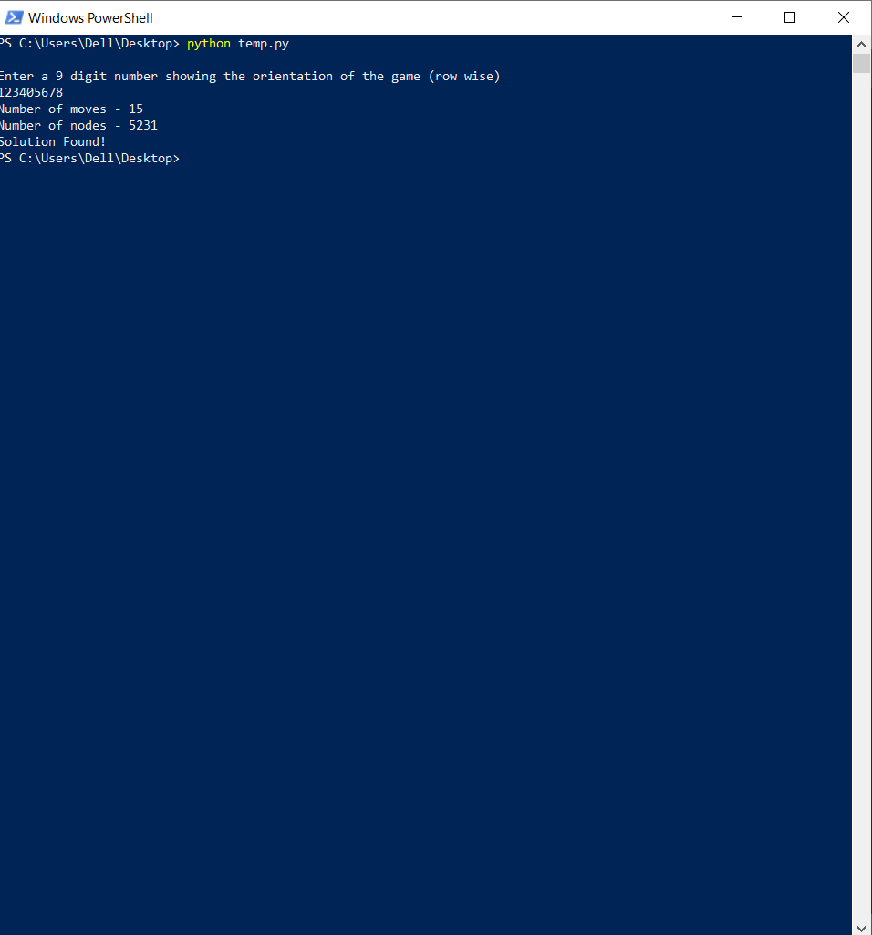
2. Implement Iterative deepening search. 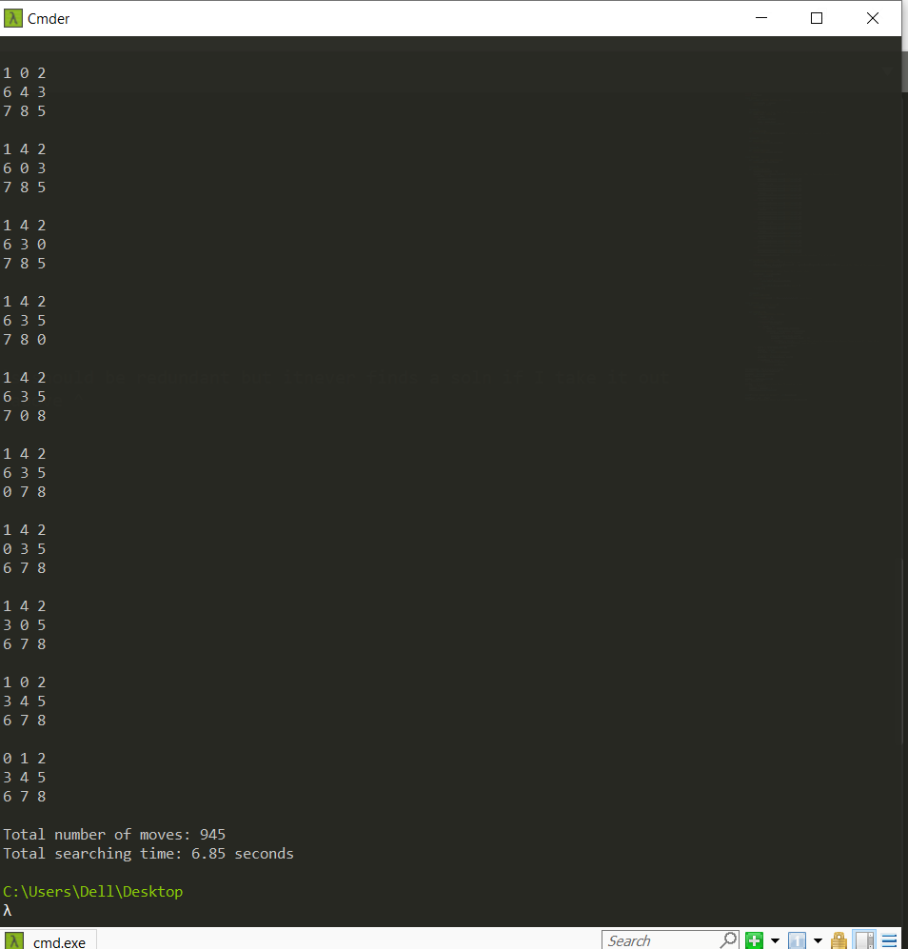
3. Implement A\* search. 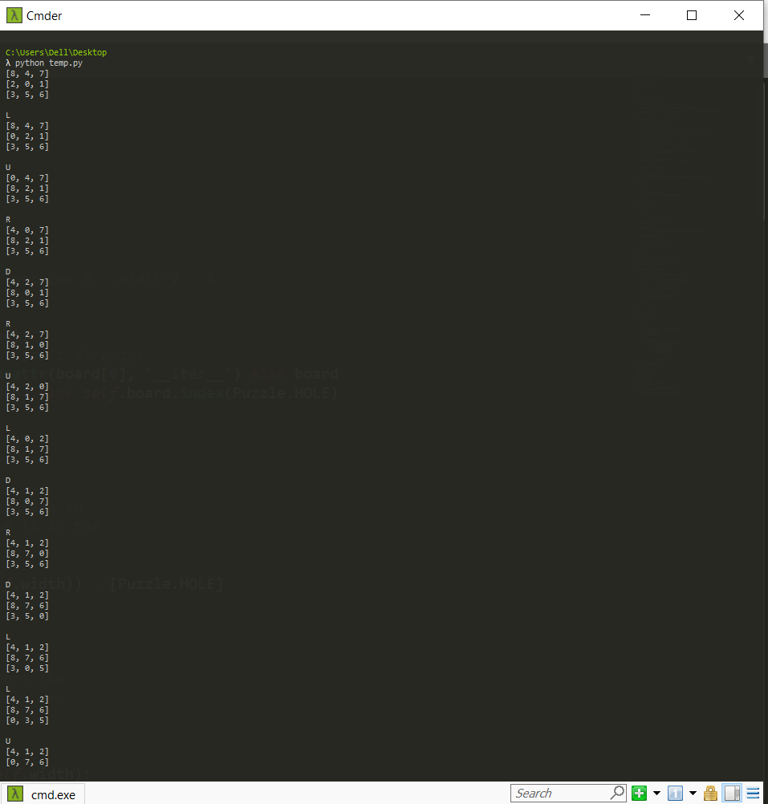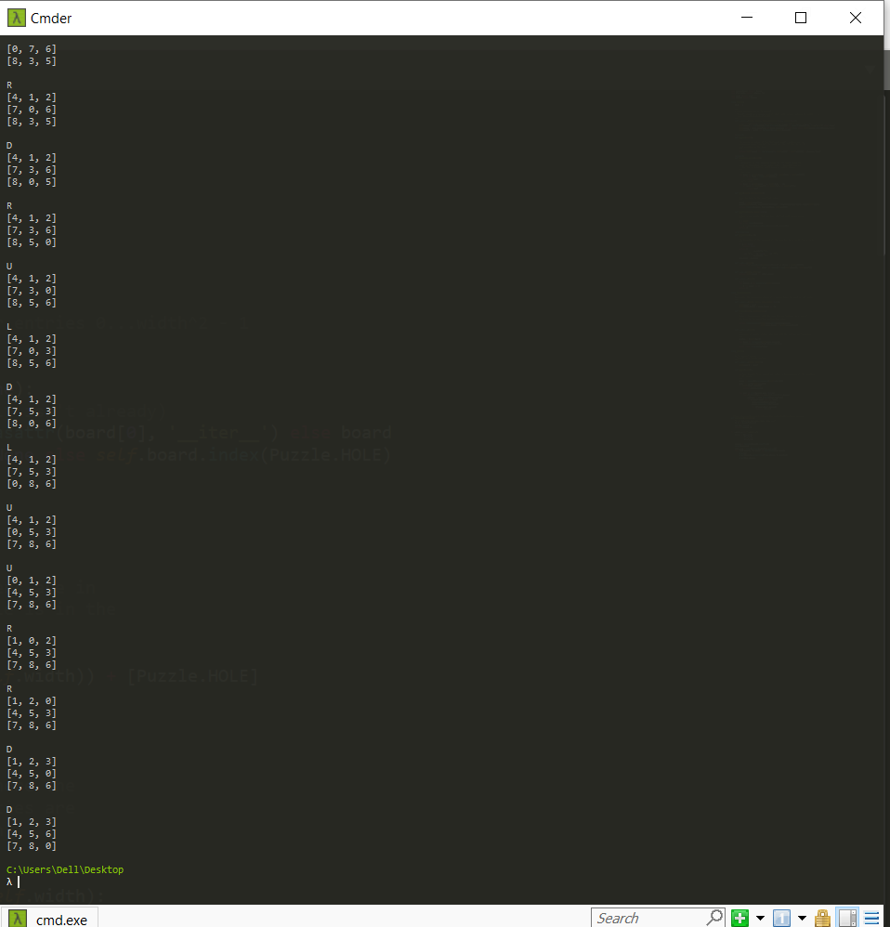
4. Implement vacuum cleaner agent. 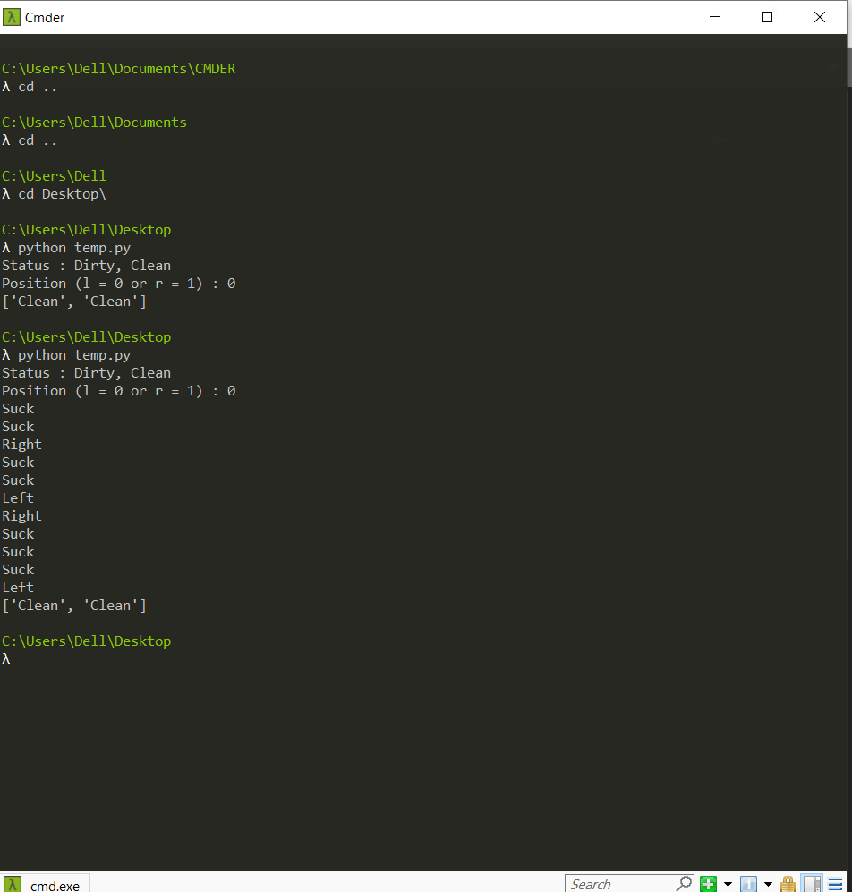
5. Create a knowledge base using prepositional logic and show that the given query entails the knowledge base or not. 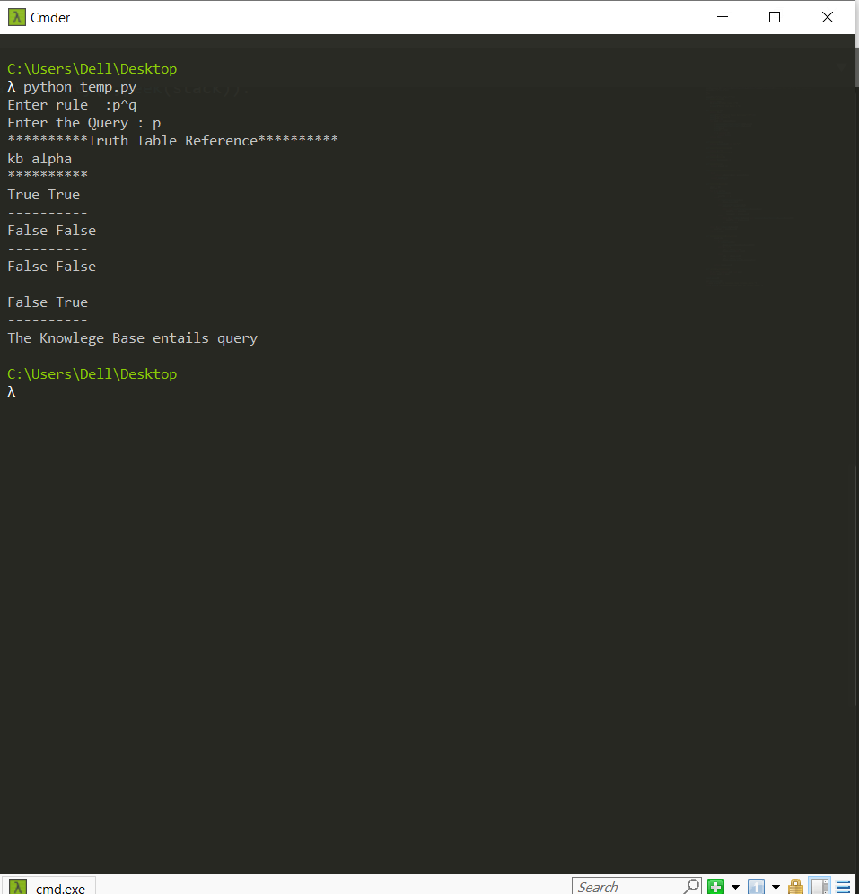
6. Implement unification in first order logic. 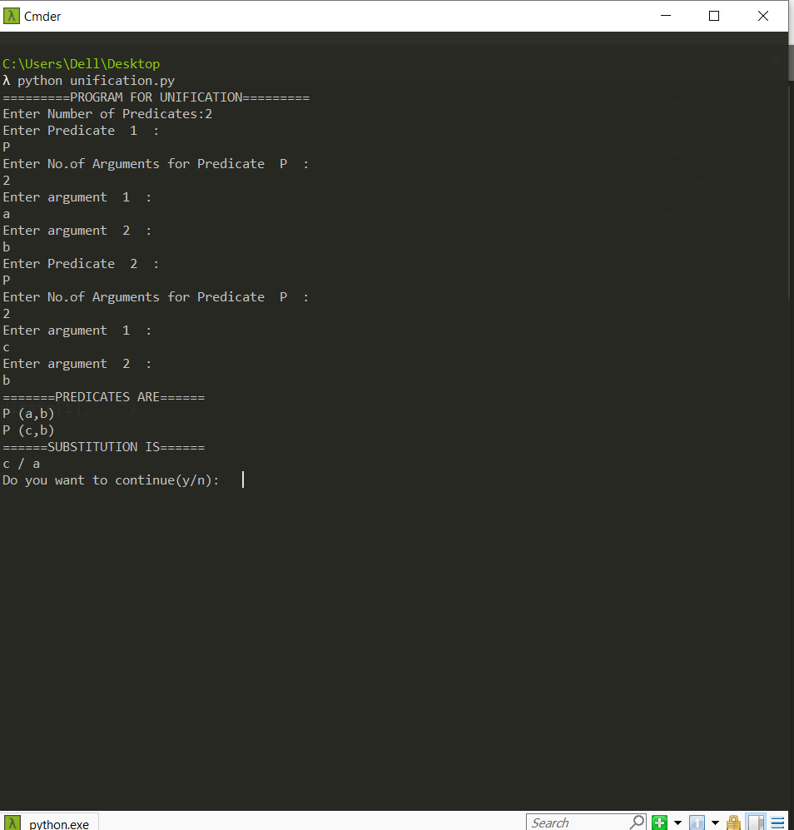
7. Convert given first order logic statement into Conjunctive Normal Form (CNF). 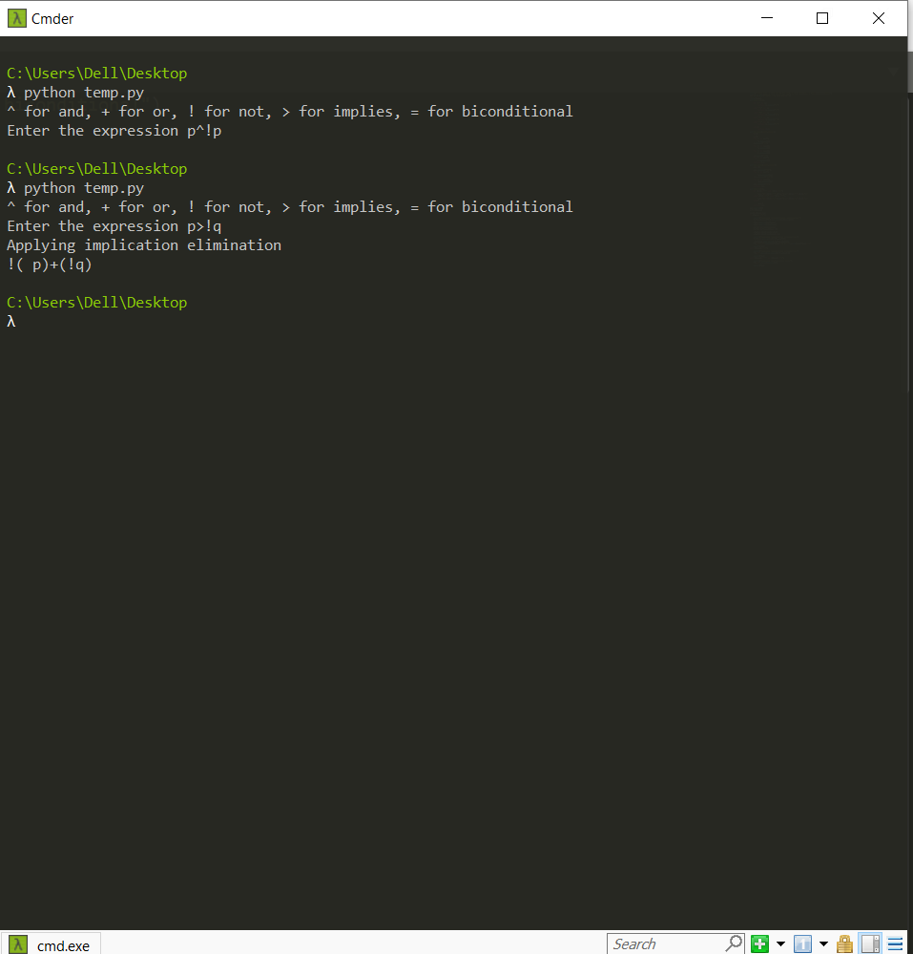
8. Create a knowledgebase consisting of first order logic statements and prove the given query using forward reasoning.

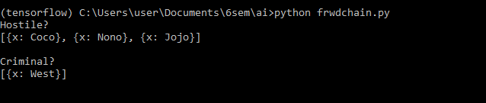

1. Demonstrate decision tree learning for a given set of training examples and test data.

Output exists in the python notebook itself